1.Auto get the last several Asm versions
Select a server from the ASM Server dropdownlist and then cllick the“Populate” button in Invoke Tab.You can see the the last several Asm versions in version dropdownlist and you can see the modules in the module name dropdownlist.

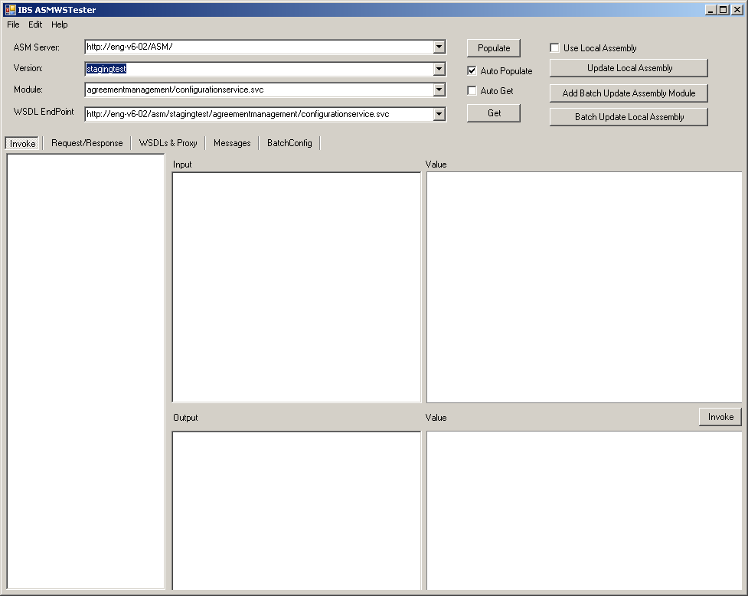

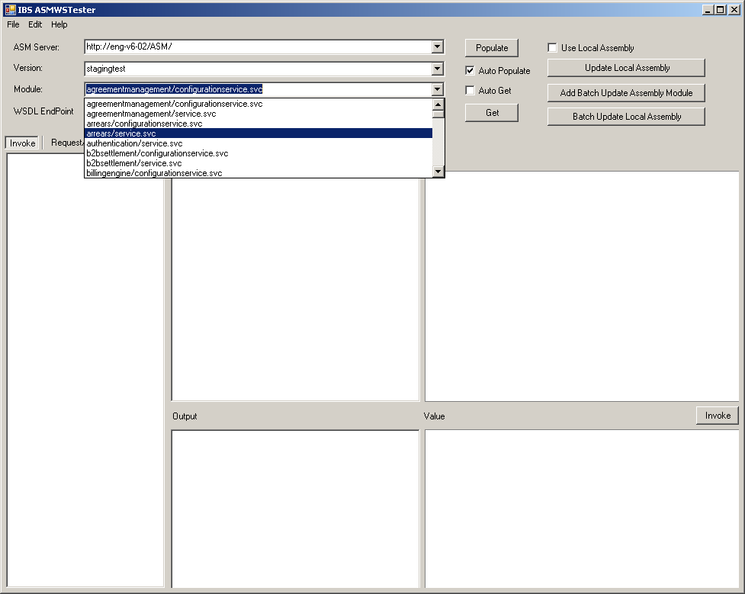

If you select a module from modules list, the “WSDL EndPoing” will be auto completed.

You can set the ASM Servers in “Menu→Edit→Options...” menu.
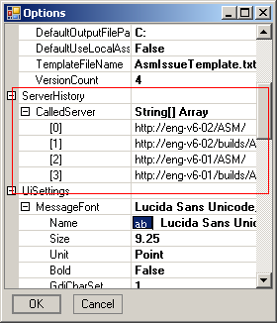

You can specify versions count in in “Menu→Edit→Options...” menu.
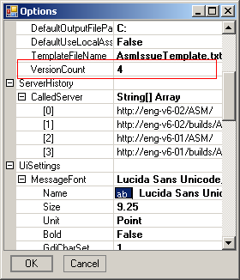

2. Set “Authentication Header” default values
Open “Menu→Edit→Options...” menu and set ConfigSettings items
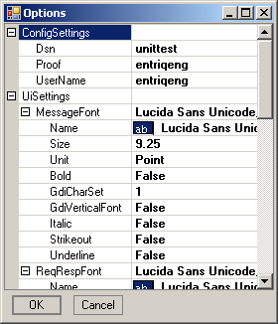

When you select a method in method tree, the Authentication Header will be auto set.
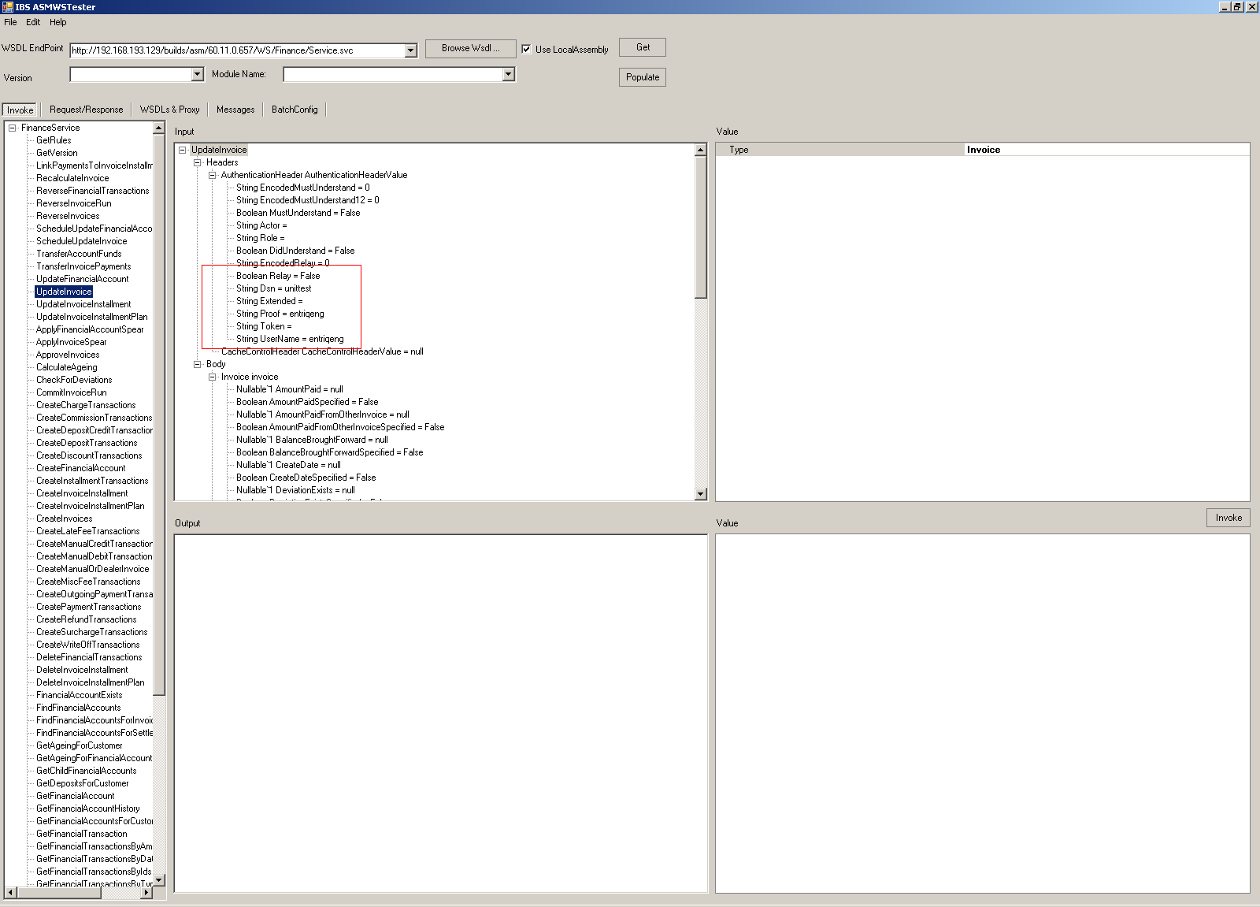

3. Save (Apply) parameters in a config file
You can click right click mouse in input tree to save and load a config file. The config file includes the parameters info of current method.

A sample config file as follows:
<GetLookups>
<Headers>
<AuthenticationHeaderValue>
<EncodedMustUnderstand value="0" type="System.String" />
<EncodedMustUnderstand12 value="0" type="System.String" />
<MustUnderstand value="False" type="System.Boolean" />
<Actor value="" type="System.String" />
<Role value="" type="System.String" />
<DidUnderstand value="False" type="System.Boolean" />
<EncodedRelay value="0" type="System.String" />
<Relay value="False" type="System.Boolean" />
<Dsn value="unittest" type="System.String" />
<Extended value="" type="System.String" />
<Proof value="entriqeng" type="System.String" />
<Token value="" type="System.String" />
<UserName value="entriqeng" type="System.String" />
</AuthenticationHeaderValue>
<CacheControlHeaderValue isNull="true" />
</Headers>
<Body>
<lookup value="ShippingOrderStatusUpdateReasons" type="LookupLists" />
<lookupSpecified value="True" type="System.Boolean" />
</Body>
</GetLookups>

4. Save output value to a xml file
You can click right click mouse in input tree to save output to an xml file.

5. Local assembly support
If you check the “Use Local Assembly” the “ASMWSTester” will generate local assembly and use it invoke method.

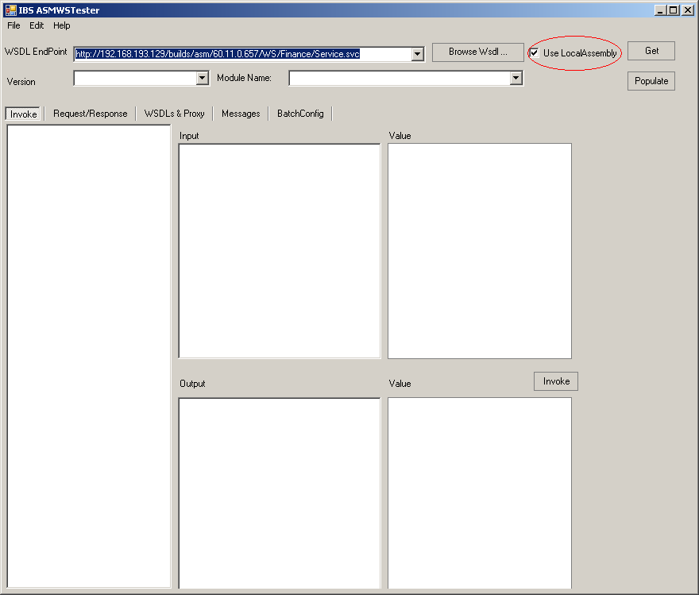

The local assembly file will be placed at the ASMWSTester’s path.
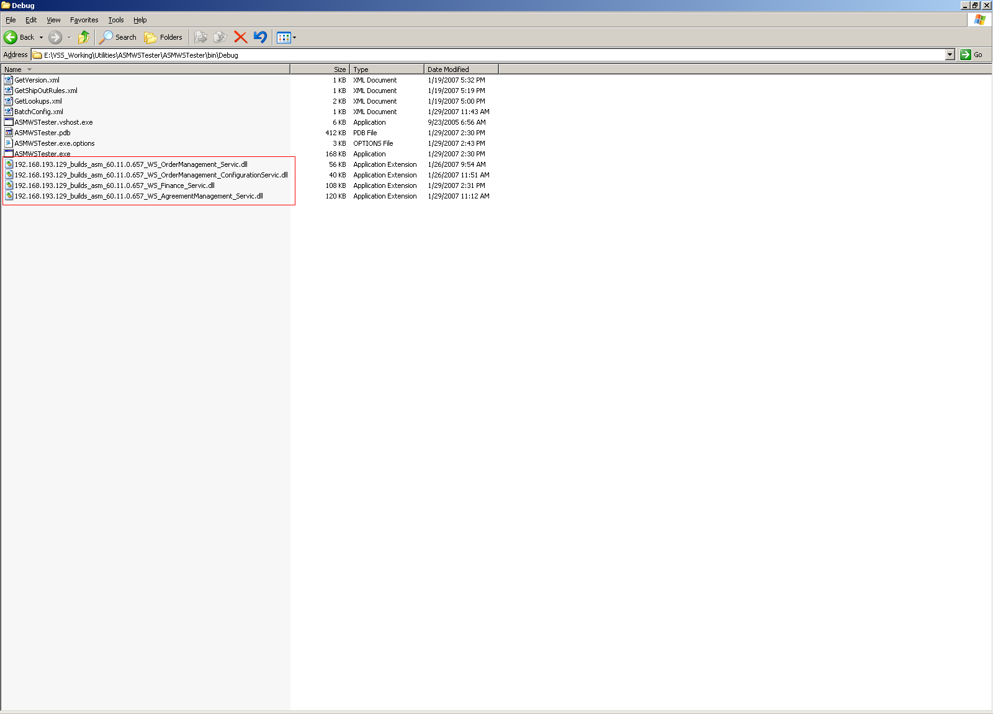

6. Nullable Decimal type support
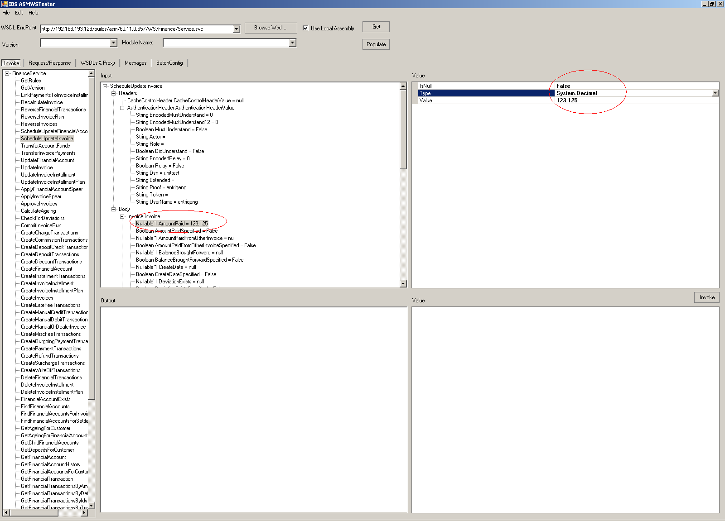

7. Run in test cases
Please see the “ASMWSBatchTester” project for more info.

8. Batch Config File support in test cases (future function)
Please see the “ASMWSBatchTester” project for more info.

9. (Batch) Update Local Assembly
If you use “Local assembly” function. You can click “Update Local Assembly” button to update Local Assembly. You also can “Batch Update Local Assembly” to Batch Update Local Assembly.
Batch Update Which Local Assembly depend on BatchUpdateAssemblySettings.You can set which version and module that you need update.If you select “autoUpdate” it will get Local Assembly using the the last two Asm versions and Carlsbad version.
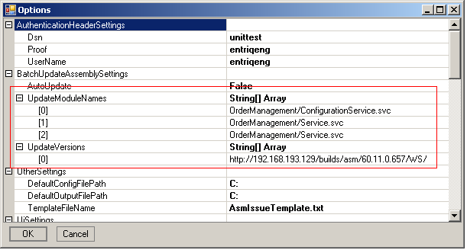

10. Auto Generate ASM issue
If you need write an ASM issue after invoke a method. You can switch “WSDLs&Proxy”tab and click right click mouse on “Wsdl” textbox and select “CopyAsmIssue” then system will auto generate an ASM issue and set it to Clipboard.The ASM issue style can be configured with a template file. A sample template as follows:

Login:[[Login]]

Database:[[Database]]

Steps to reproduce:

Use Web Service Studio with
URL:[[EndPointUri]]
Call [[MethodName]] method with parameter as the only parameter (see S1 below).

Expected result:

Actual result: [[ActualResult]]

S1
[[InputParameter]]

You can modify it as you want.

Notice:when you are using “Local Assembly” You can not see the WSDL info,so you can not use this function.

11. PSM log support (future function)

